**User Help:**

**User Documentation:**

### **Home Page**

This screen allows users to log in either as a service recipient or as staff. Additionally, the screen supports multiple languages. Language selection buttons are located at the bottom right of the screen. Clicking on a specific language button changes all system text to the selected language from this screen, users can choose one of two paths based on their login type: attendance registration for service recipients or staff login for staff members. The text will be displayed in the selected language throughout the use of the system.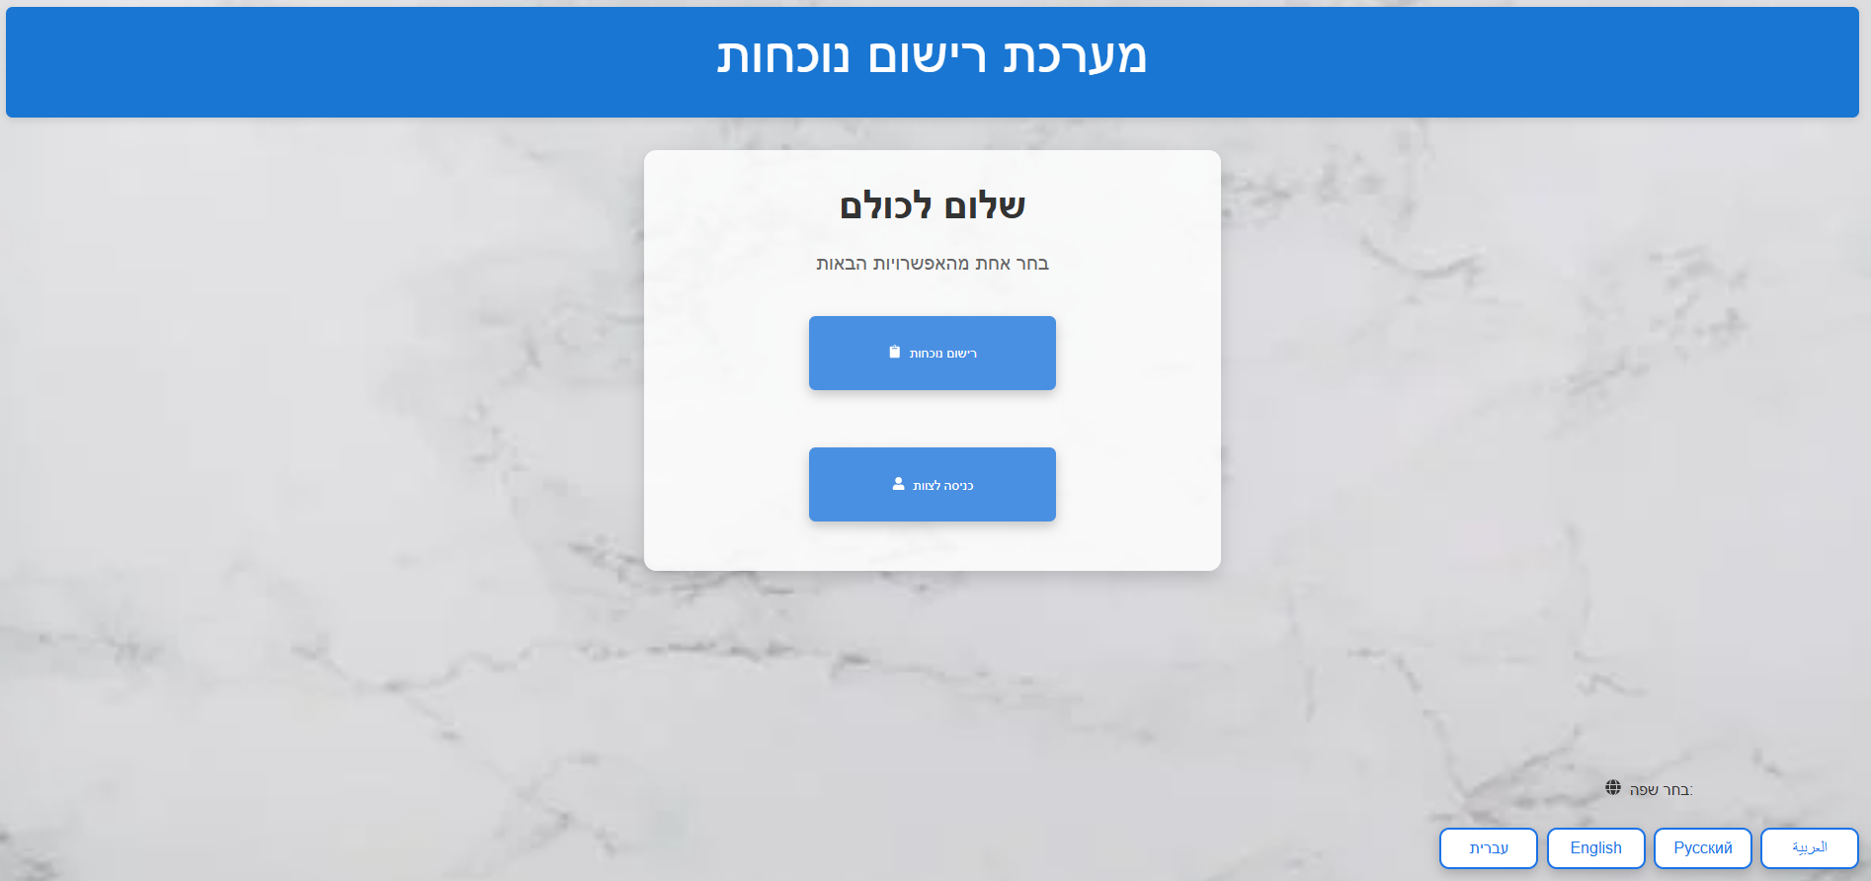

#### 

#### **Guide Selection**

After selecting "Attendance Registration" on the main screen, the service recipient proceeds to the "Guide Selection" screen. Here, photos of all group guides at the Carmey Gil center are displayed, with the name of each guide appearing below their photo. To continue the registration process, the service recipient selects their guide. When the user clicks on the guide, the system provides voice feedback, the name of the guide.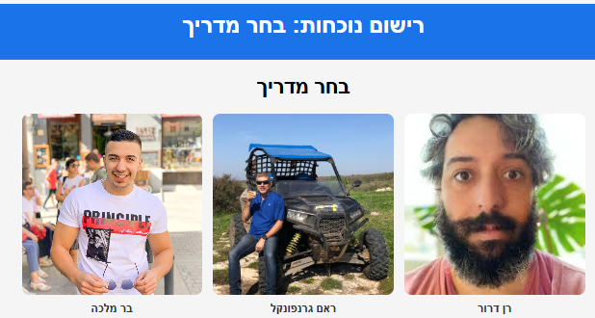

**Service Recipient Selection**

Once the service recipient selects their guide, they proceed to the "Service Recipient Selection" screen. This screen displays photos of all service recipients belonging to the selected guide's group. Similar to the previous screen, each photo is labeled with the recipient's name. The recipient selects their photo to proceed. When the user clicks on receive the service, the system provides voice feedback, the name of the service recipient.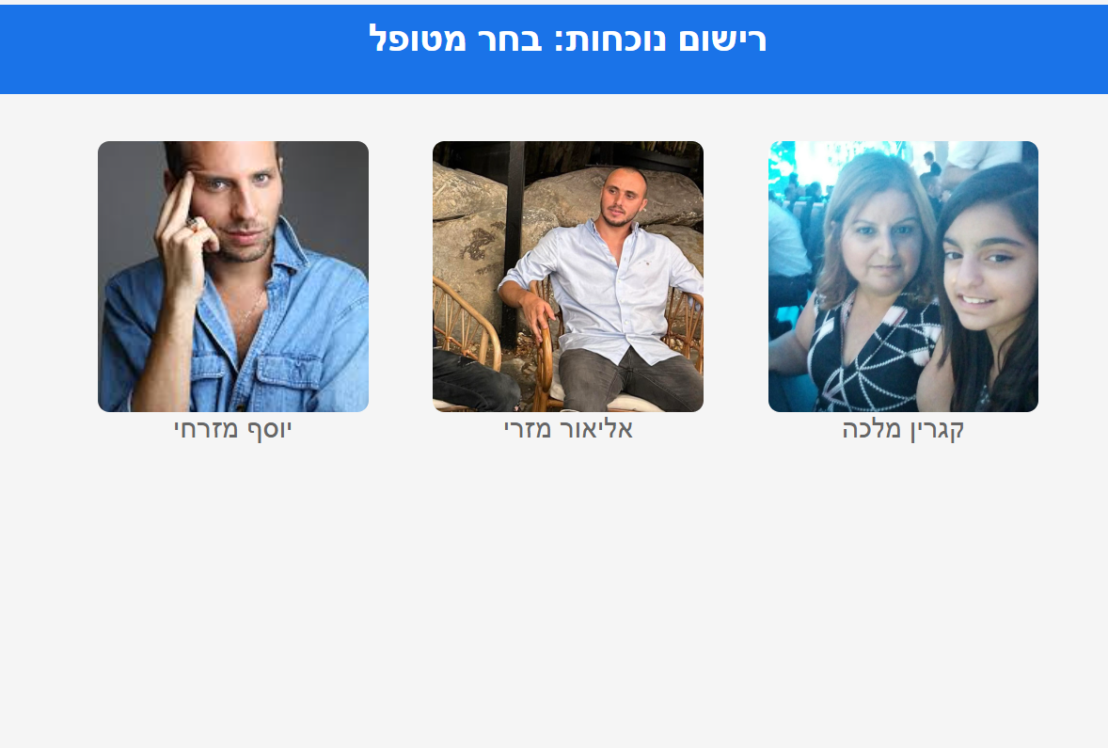

#### 

#### **Emotion Selection**

After selecting their photo, the service recipient moves to the "Emotion Selection" screen. This screen displays emojis representing various emotions. The recipient selects the emotion that reflects how they feel at the time of registration. At this point, the attendance registration process is complete, and the information is saved in the system. If the service recipient chooses an angry or sad emoticon, an email will be sent to the manager with the details of the service recipient.

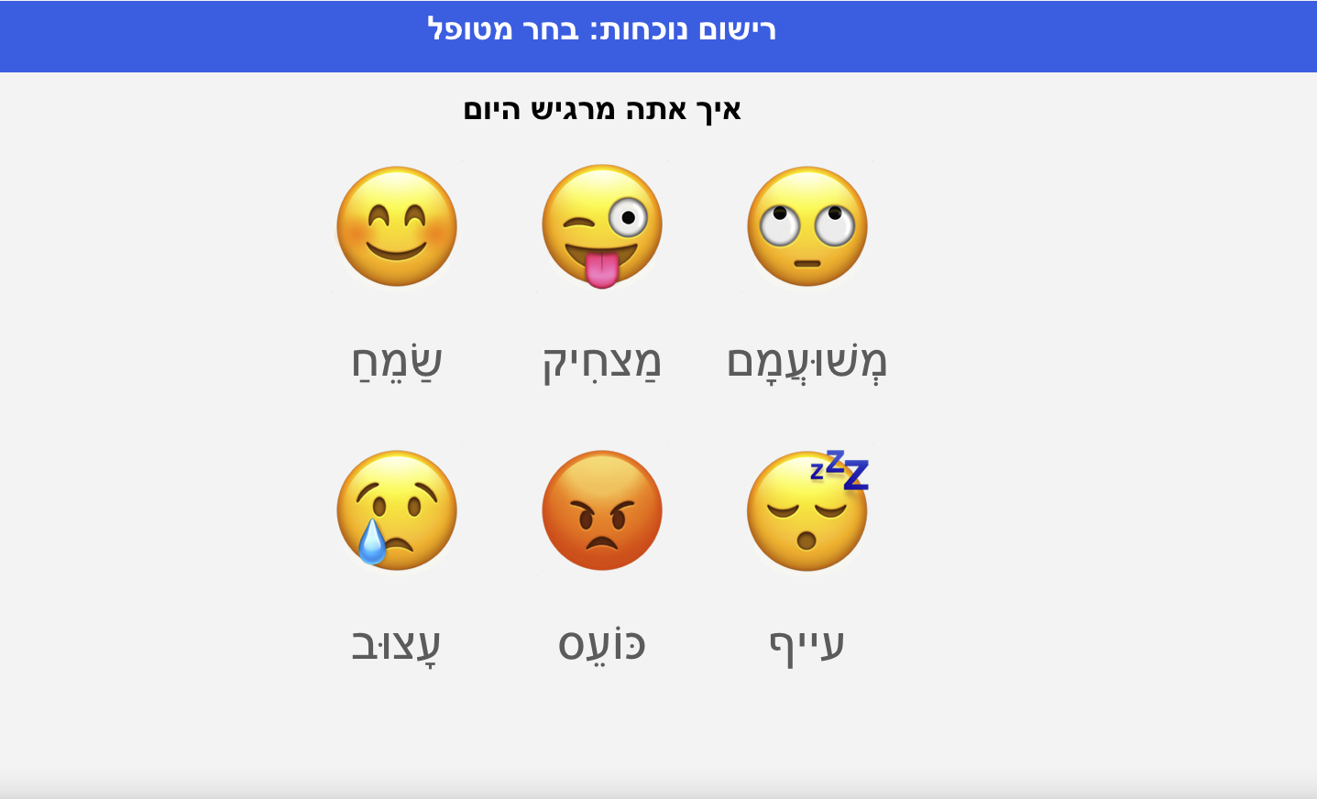

### 

### **Login Screen - Staff Members**

In this screen, staff members are required to enter their username in the top field and their password in the bottom field. The system verifies that the username and password are correct. Upon successful login, the system directs the user to the staff member dashboard.

The on-screen keyboard allows users to enter data into the system. It is designed to support platforms such as tablets, ensuring accessibility for devices without a physical keyboard. This keyboard appears on any screen where data entry is possible.

Login details for check:

username - [barmalka1419@gmail.com](mailto:barmalk1419@gmail.com)

password - 123456

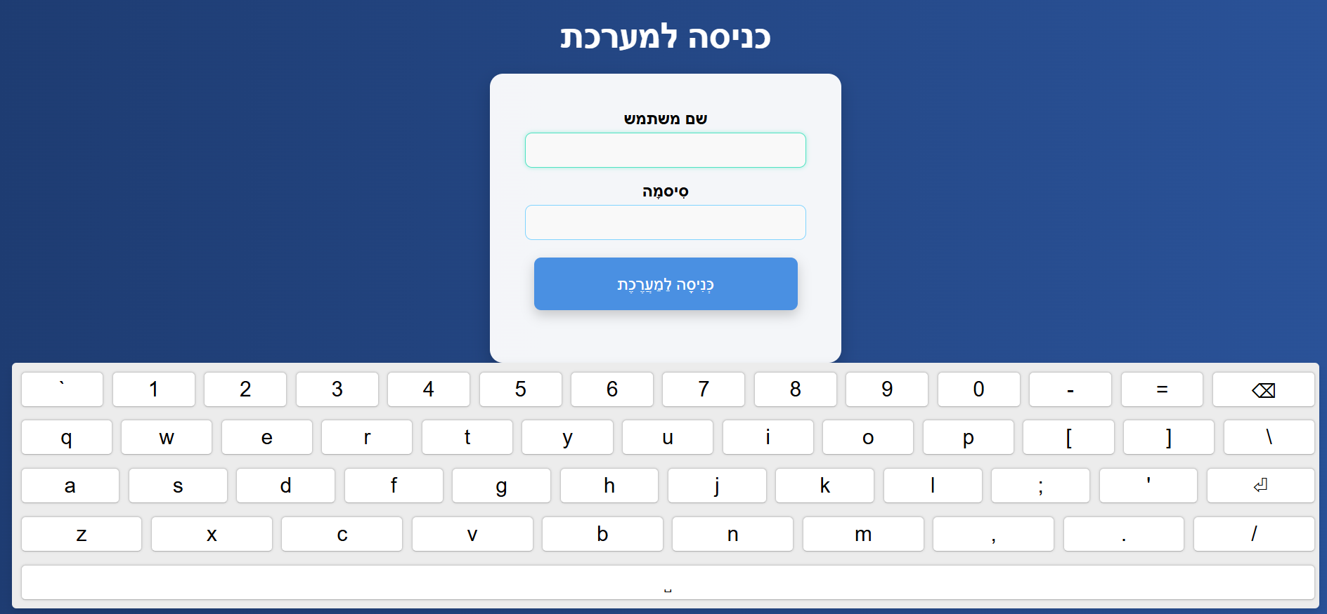

**Staff Members Dashboard**

After logging in as a guide, the main dashboard for staff members appears. This dashboard provides four options: Manage Attendance, Manage Service Recipients, Manage Staff Members, and Generate Reports.

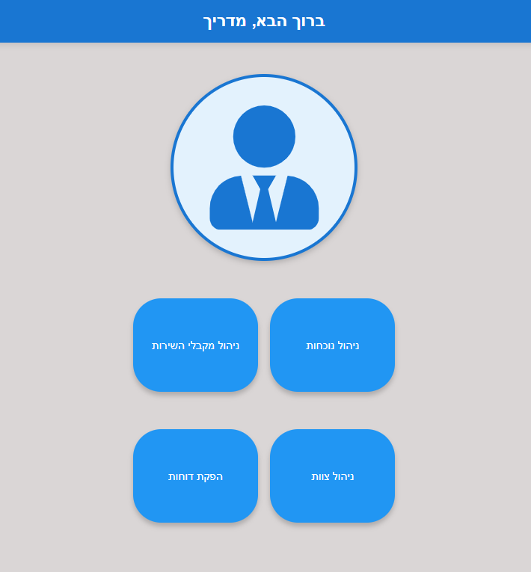

#### **Manage Attendance**

In this screen, the guide can manage the attendance records of the service recipients. A list of all service recipients is displayed on the left side of the screen. To update a specific recipient's attendance, the guide selects their name. Attendance records, including entry and exit times and four additional options: Edit Attendance, Delete Attendance, Update Score, and add attendance manually.

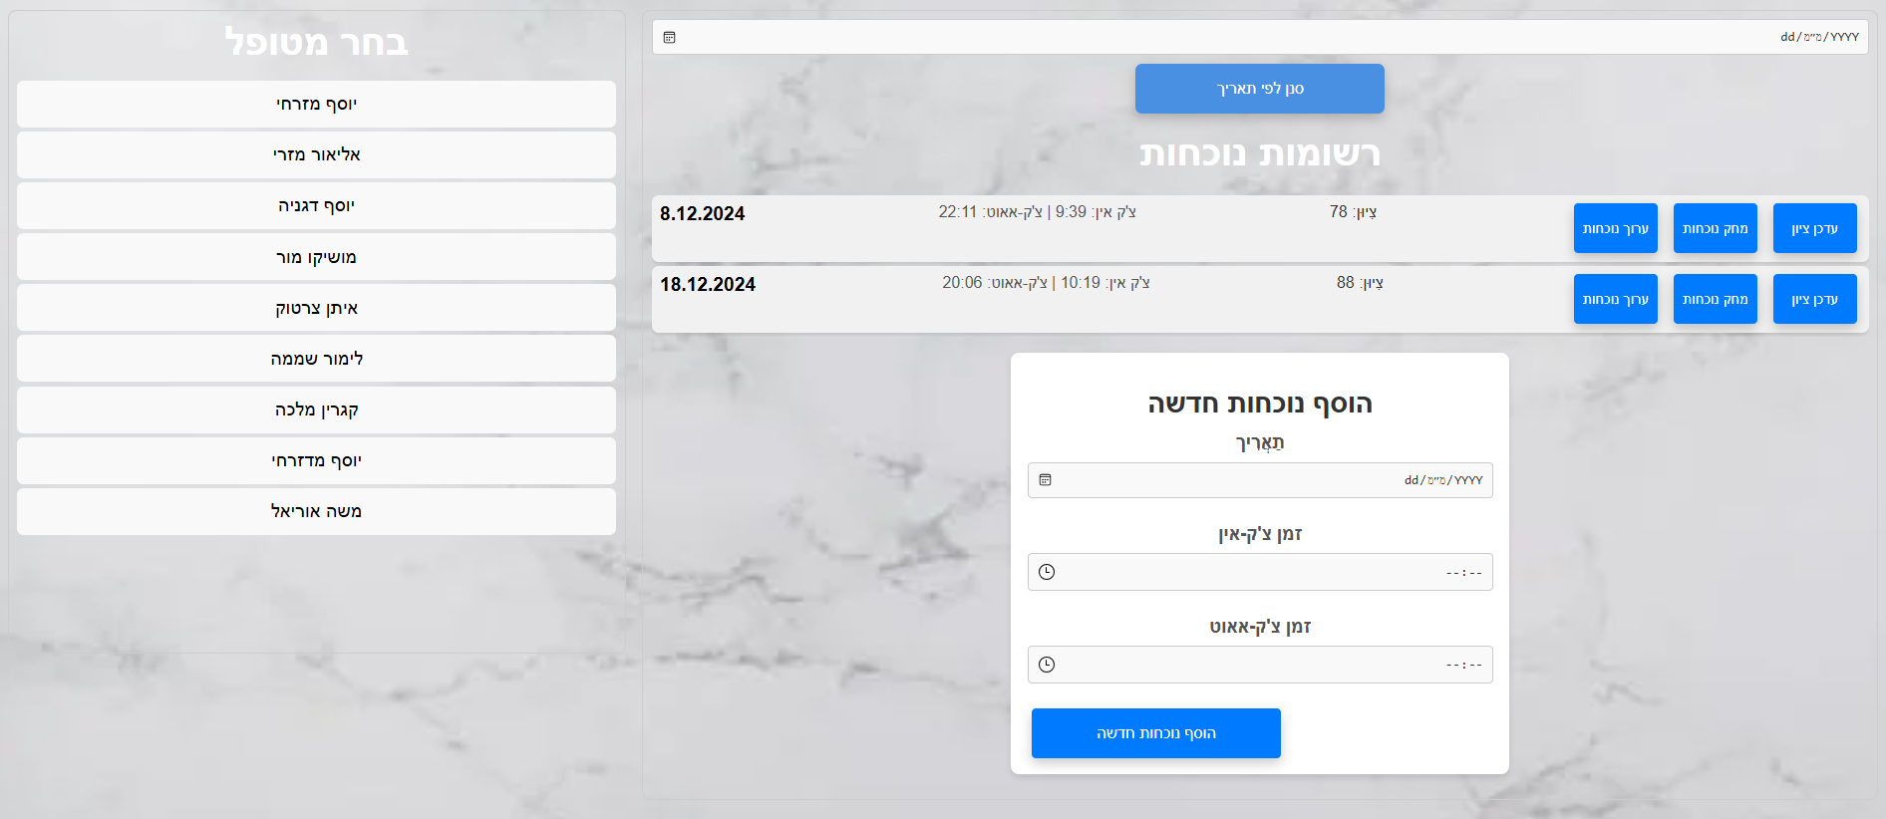

**Edit Attendance**

When we click on the option to edit attendance that appears next to each of the attendance records, we will reach this screen. On this screen, we can edit the date and time of the record we want. The guide can click a filter and choose a date he wants to focus on. The screen has three fields: Date, Entry Time, Exit Time. These fields display the times that are registered in the system. To update the date, we click on the small calendar on the left side of the field and use it to select the date that we want to enter into the record. Similarly, we will update the attendance hours using the small clock that appears in each of the fields: Entry Time and Exit Time. To update the attendance and save it in the system, we click on the blue "Update" button. To cancel the operation and not make any changes, we click on the red "Cancel" button**.**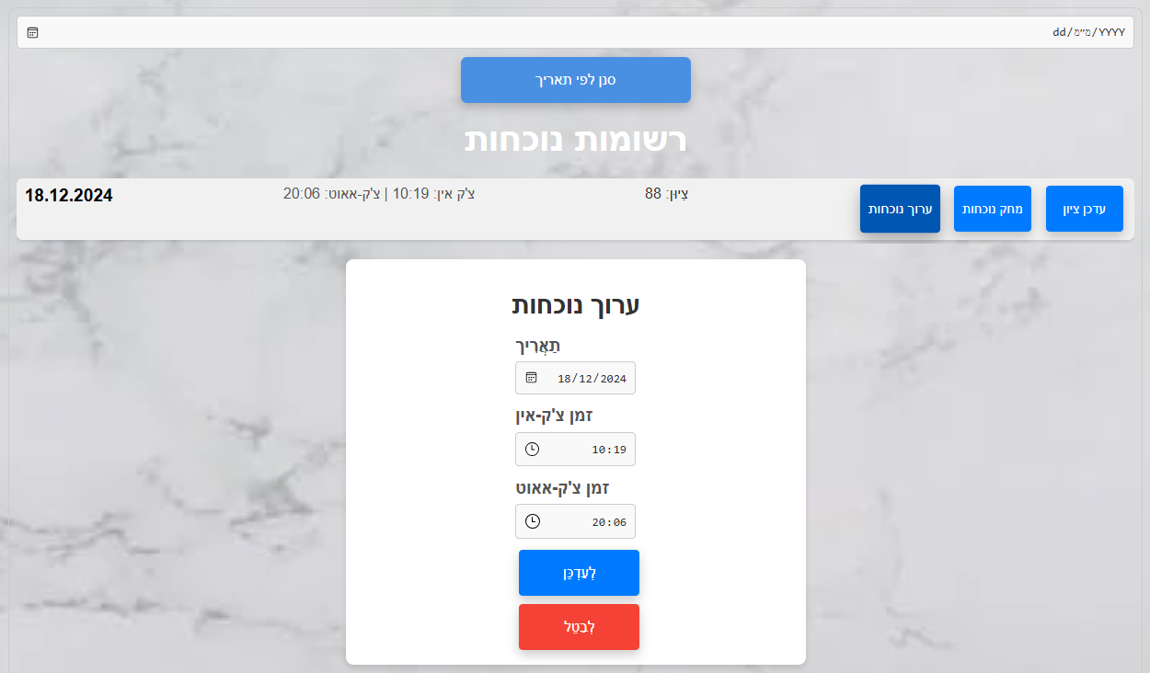

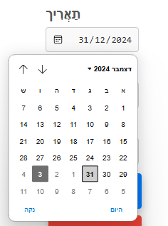

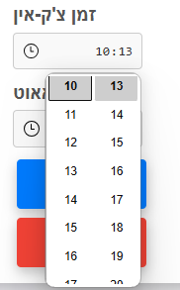

#### 

#### 

**Delete Attendance**

To delete an attendance record, click the Delete Attendance button which appears next to it.

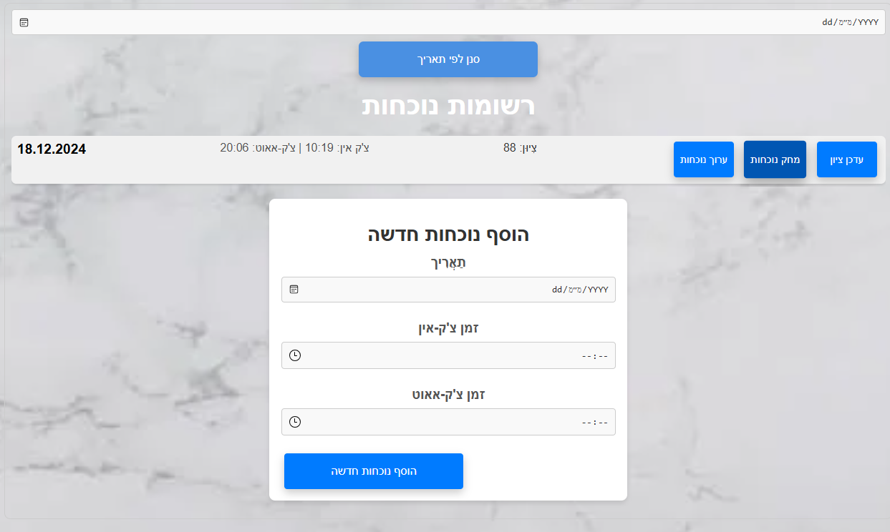

**Update grade**

When we want to update a grade for a particular record, we click on the "Update Grade" button that appears next to it. When we click on the button, no grade will appear for a new record and for a record that already has a grade, a window will open with the number with the grade. When we stand on the right part of the field where the grade appears, we will have two arrows (up and down) when clicking on the up arrow will increase the grade by 1 and clicking on the down arrow will decrease the grade by 1. In addition, the guide can update through the keyboard by entering a number. When we reach the desired grade, we click on the left blue button "Update Grade" and the grade will be updated in the attendance record. To cancel the operation, we click on the left red button "Cancel Update". 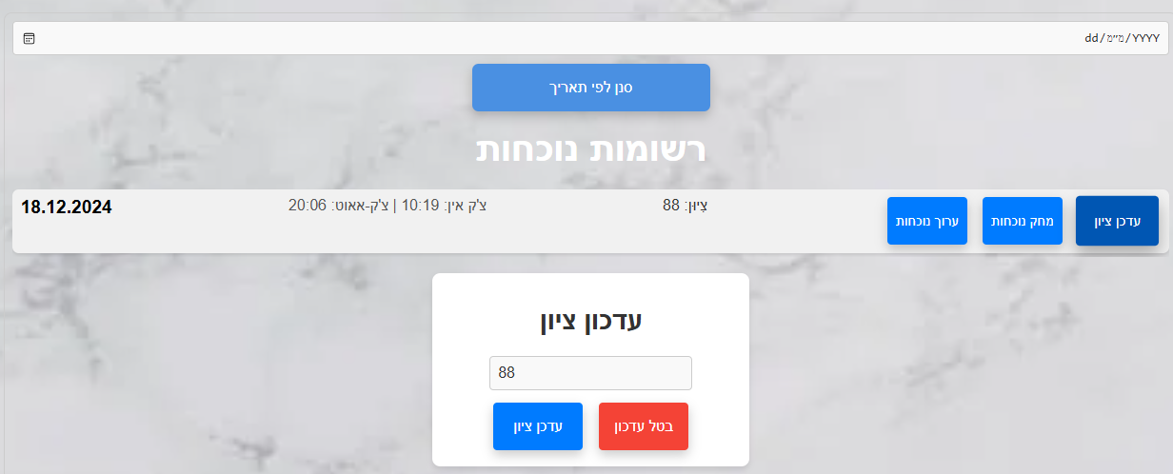

**Add Attendance**

To add a new attendance record, we will fill in the following fields: date, check-in time, check-out time.To enter the date, we click on the small calendar on the left side of the field and use it to select the date that we want to enter into the record. Similarly, we will enter the attendance hours using the small clock that appears in each of the fields: Entry Time and Exit Time. The guide can enter these details using the keyboard. To add the attendance record with the data we filled in, we click the "Add new attendance" button.

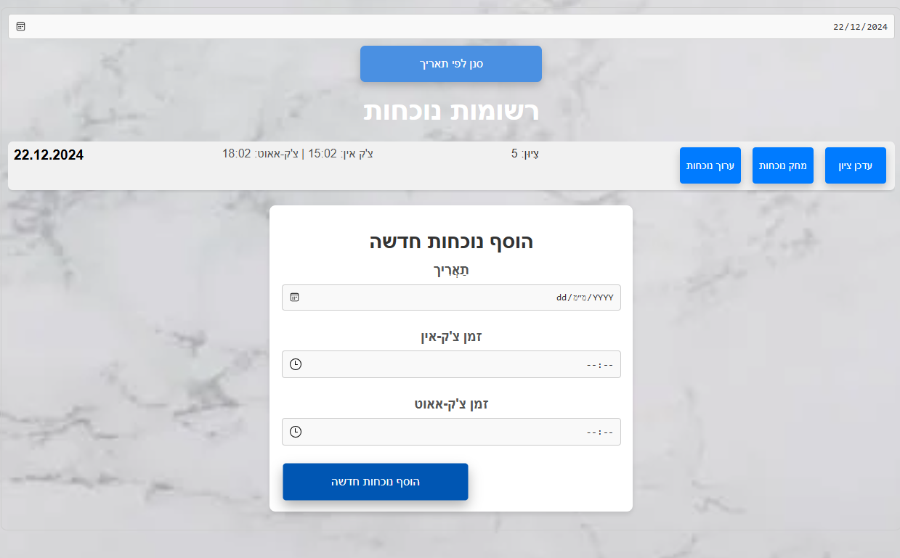

### 

### **Generate Reports**

On this screen, the staff member selects a month at the top of the page for which the report will be generated. To select the date, they use the calendar that appears on the left side of the top field. At the bottom of the screen, the staff member enters an email address to which the report should be sent. They can type the email address using an intuitive keyboard that opens at the bottom of the screen. After filling in the required details, the staff member clicks the "Generate Report" button, and a report containing all attendance data stored in the system for the selected month is sent to the specified email address.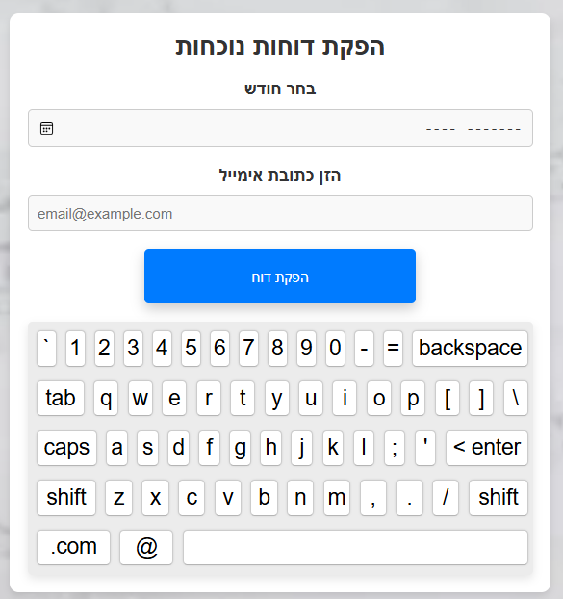

#### 

#### 

#### **Service Recipient Management**

In this screen, three options are available: Edit Service Recipient, Delete Service Recipient, and Add Service Recipient.

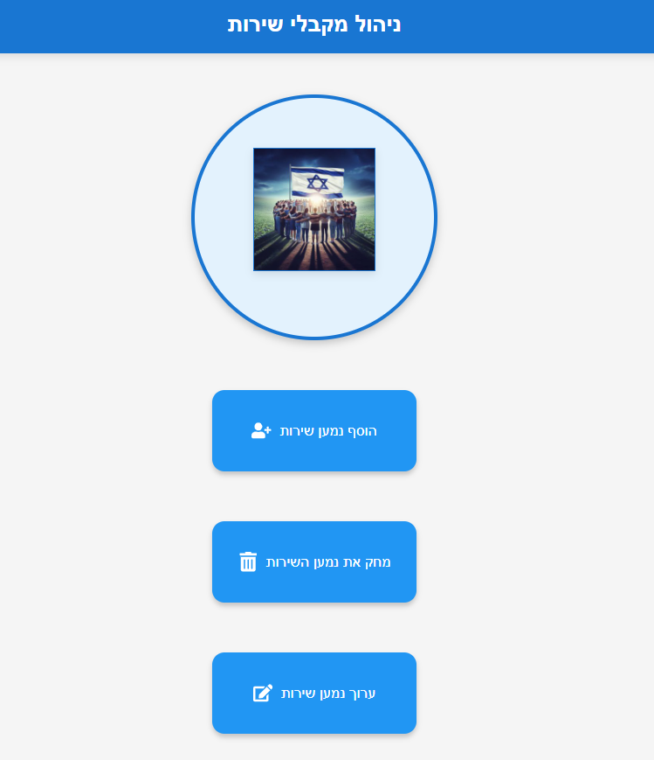

##### **Add Service Recipient**

Clicking on this option opens a screen for entering all the required details for the new service recipient: ID, name, photo, and group. To select the guide assigned to the service recipient, the user clicks on a dropdown menu, which displays a list of all the guides in the center, allowing them to choose the desired guide. The guide then enters the remaining details using the keyboard and clicks the "Add" button at the bottom to save the new service recipient.

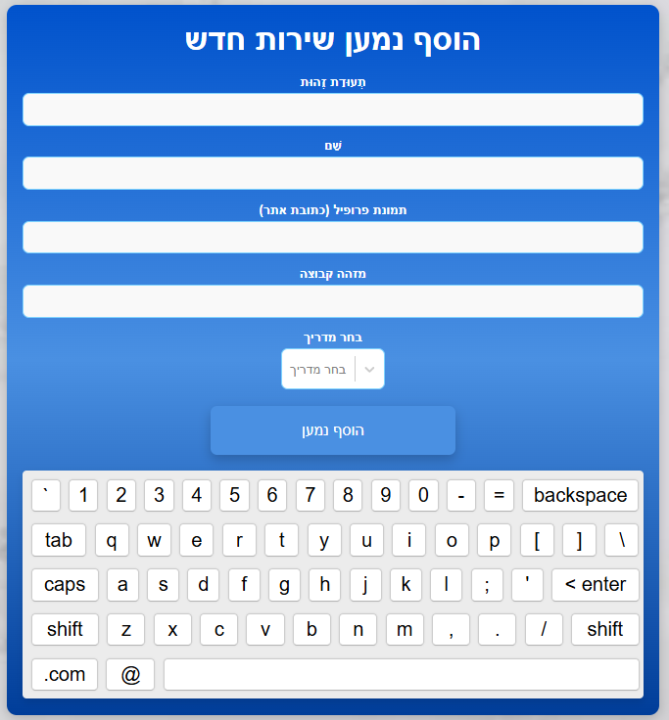

##### 

##### 

##### 

##### 

##### **Edit Service Recipient**

This screen displays all service recipients in the system. To edit a recipient, the guide clicks the photo of the recipient, the system loads the data about that recipient. Once selected, all fields: ID, name, email, photo, group, and guide appear for editing. The guide changes the details that he wants to change. A keyboard pops up to allow changes. After the updates, the guide clicks the "Save Changes" button to save the edits.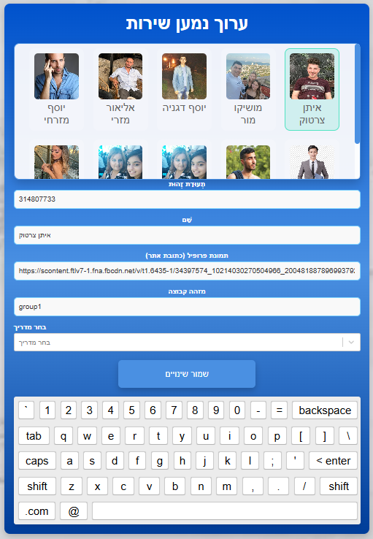

##### **Delete Service Recipient**

This screen displays all the service recipients. To delete a recipient, the manager clicks their photo and then the "Delete" button at the bottom.

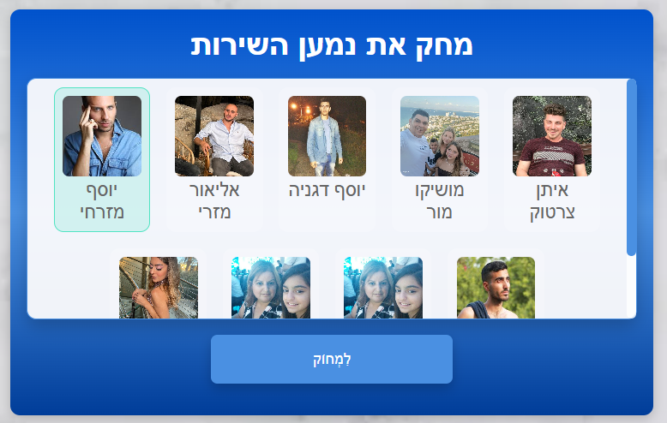

### 

**Staff Management**

This screen, similar to the Service Recipient Management screen, has the same staff member management options: Edit staff Member, Delete staff Member, and Add staff Member.

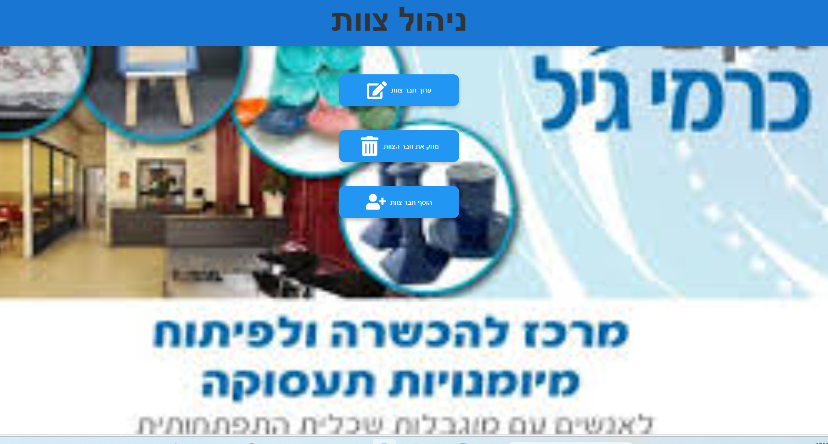

#### **Edit Staff Member**

This screen displays all guides with their photos and names. To edit a guide, click their photo. the system loads the data about that guide. Once selected, all fields (ID, name, email, password, and image link) appear for editing. A keyboard pops up to make changes.

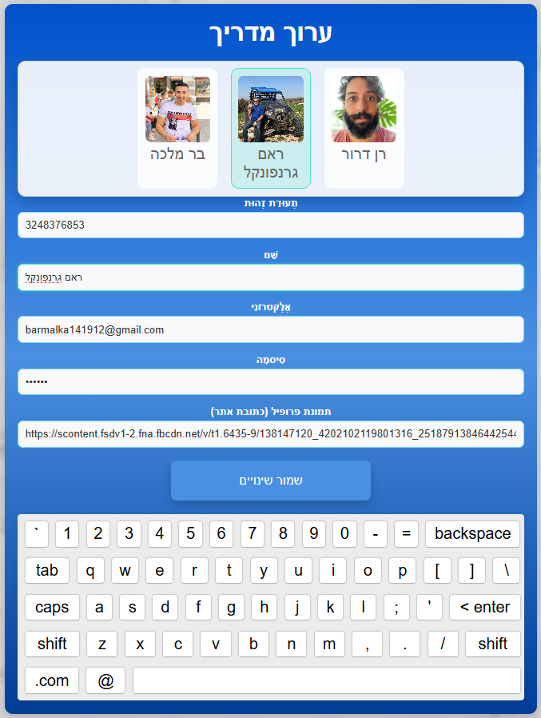

#### **Delete Staff Member**

This screen displays all guides. To delete a guide, the manager clicks their photo and then the "Delete" button at the bottom.

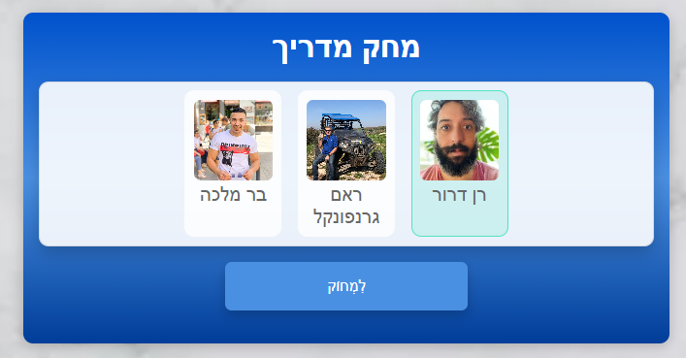

#### **Add Staff Member**

Clicking this option opens a screen to input details for new staff members: ID, name, email, password, and image url. The manager enters the details using the keyboard and clicks the "Add Staff Member" button at the bottom to save the new staff member.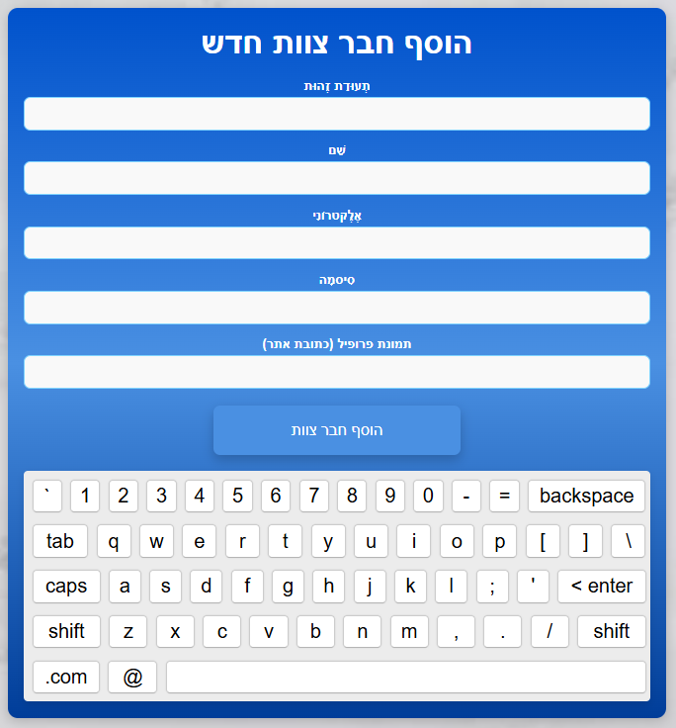

**Explanation how to add an image link via Facebook:**

This operation can only be done via computer. Log in to Facebook and select the picture of the user you want to add to the system. After you have selected the picture, hover over it and right-click. Then click "Open the image in a new tab" as shown in the example.

At the Carmey Gil Center, a dedicated Facebook account will be created, containing photos of guides and service recipients. This setup will allow the center to easily manage and update images. By using Facebook, the process of adding or updating images becomes simple and efficient, ensuring that all relevant pictures are accessible.

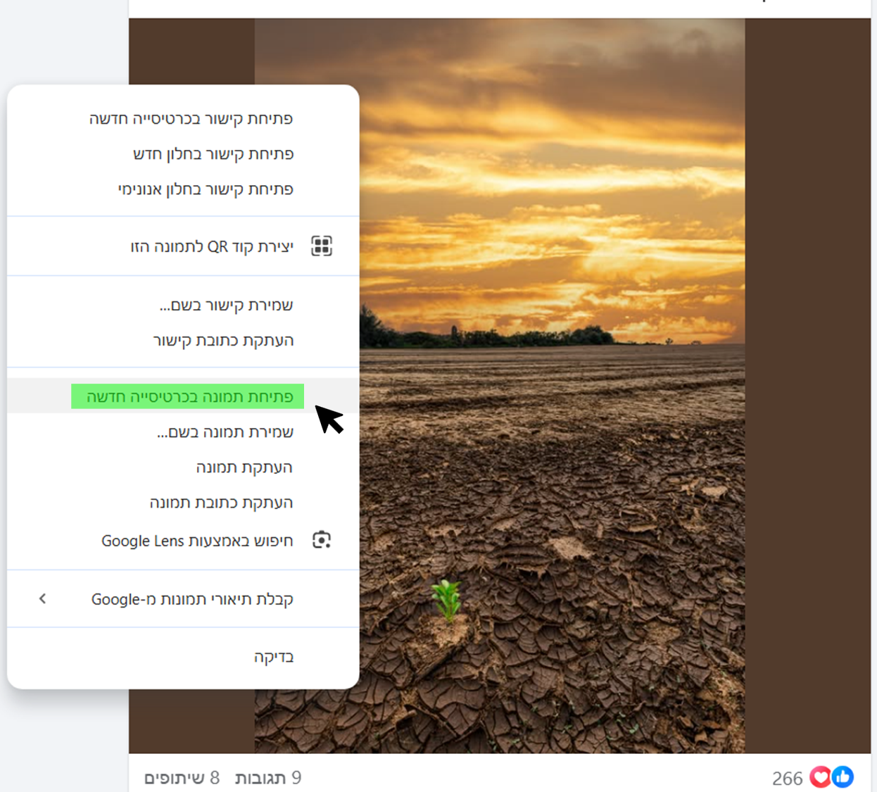

Now we will take the image URL from the new tab that opened for us.

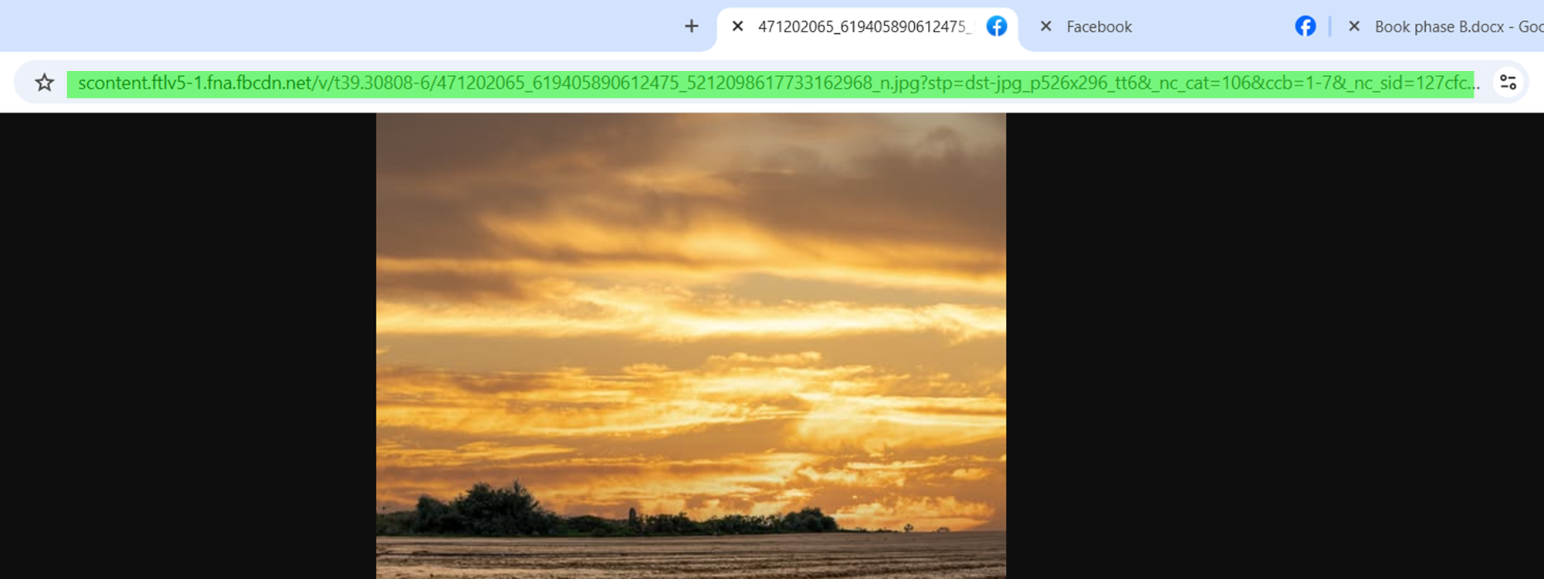

To create an initial object, paste the image address in the "imageUrl" field.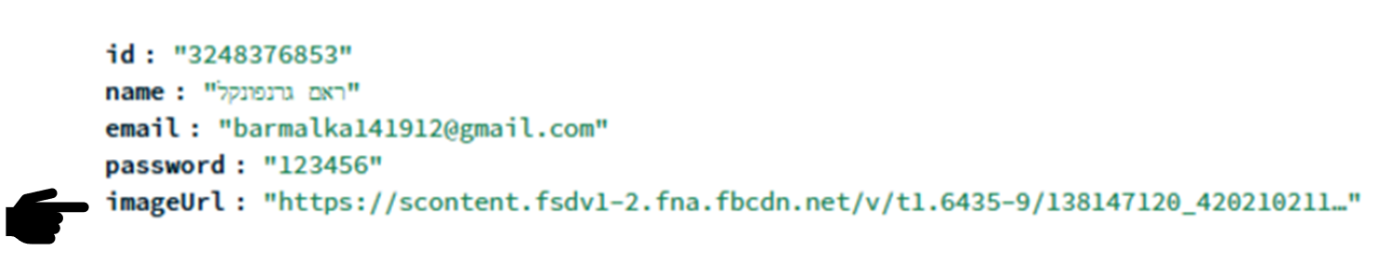

To add an image as part of the process of adding a service recipient/guide, paste the link in the "profile photo" field on the Add Service Recipient/Guide page.

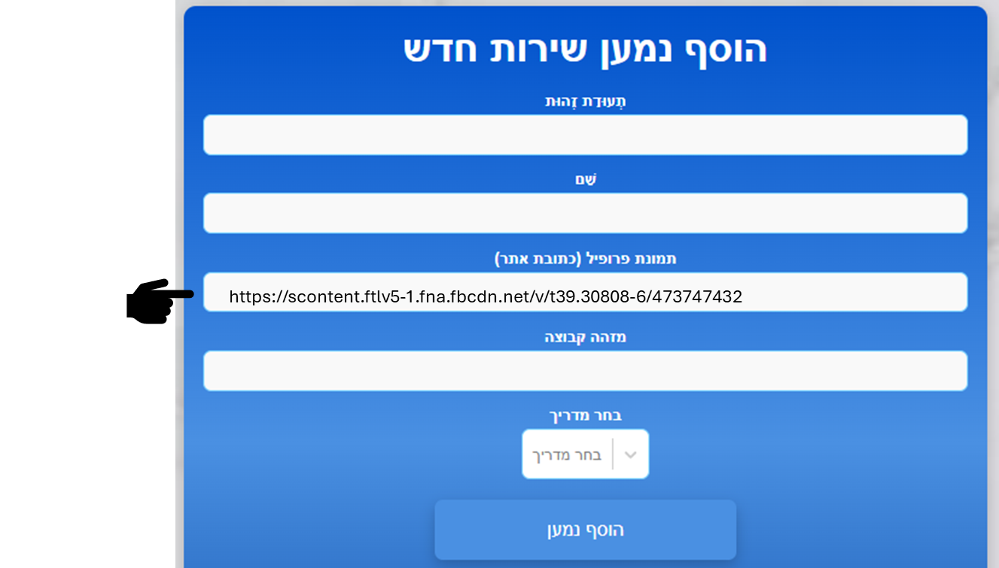

**Explain how to set up an email for notifications:**

Changing the Sender Email

To change the sender email (the email from which alerts are sent), follow these steps:

1. Replace the value in the **user field** – Update the email address under auth: { user: 'example@gmail.com' } to the new sender email.
2. Generate an App Password – If using a Gmail account, generate an App Password through the account security settings instead of using the regular password. Enter the new password in the **pass field.**

Changing the Recipient Email for Alerts

To change the email address that receives the alerts (defined in the **to field**), replace the existing email with the desired recipient’s email.

Once updated, alerts will be sent to the new email whenever a user reports a negative emotional state.

The following code snippet is located in backend/server.js

